Adding a new user flow

Admin Flow:

- Admin user goes to the Users page, There the admin enters the user’s full name & email into this screen.
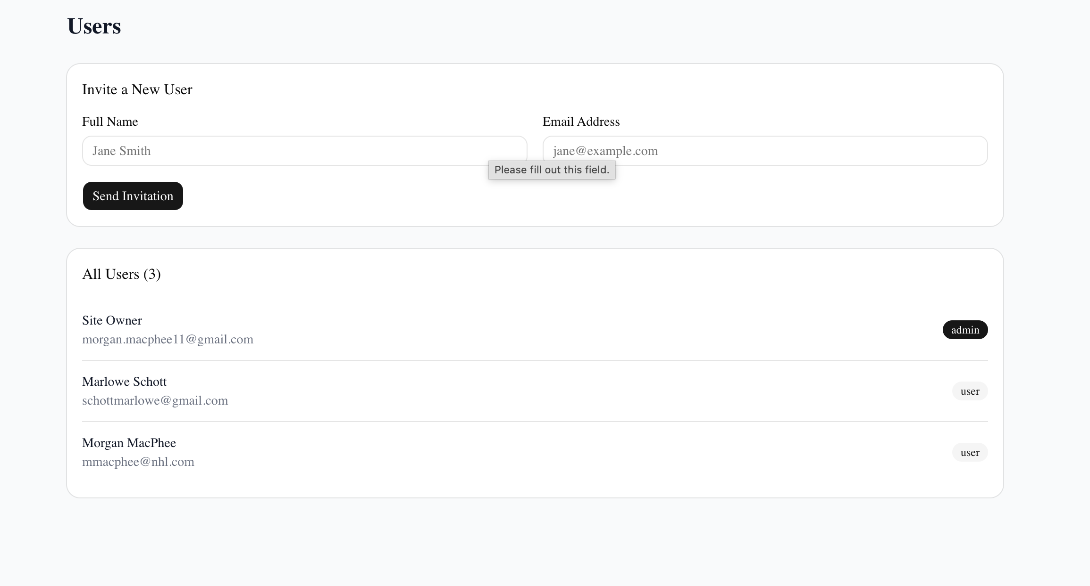
- Email is then sent to the user and the user is added to the list below as a User. This is the end of the flow.
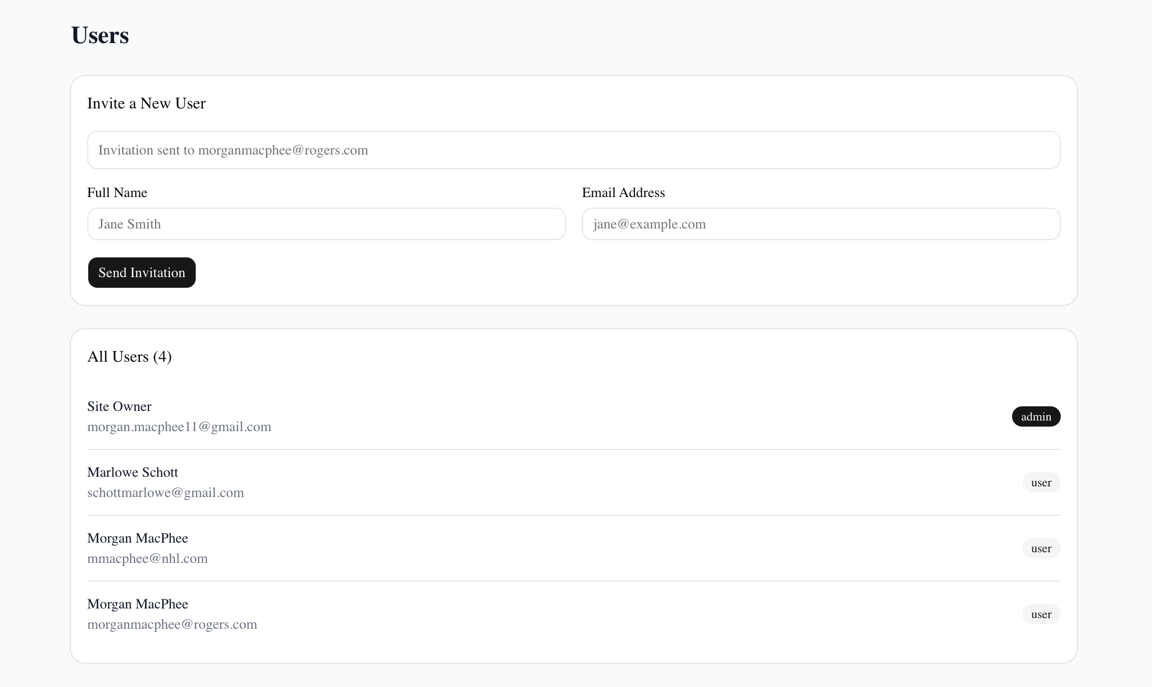

User flow:
- The user receives the email below
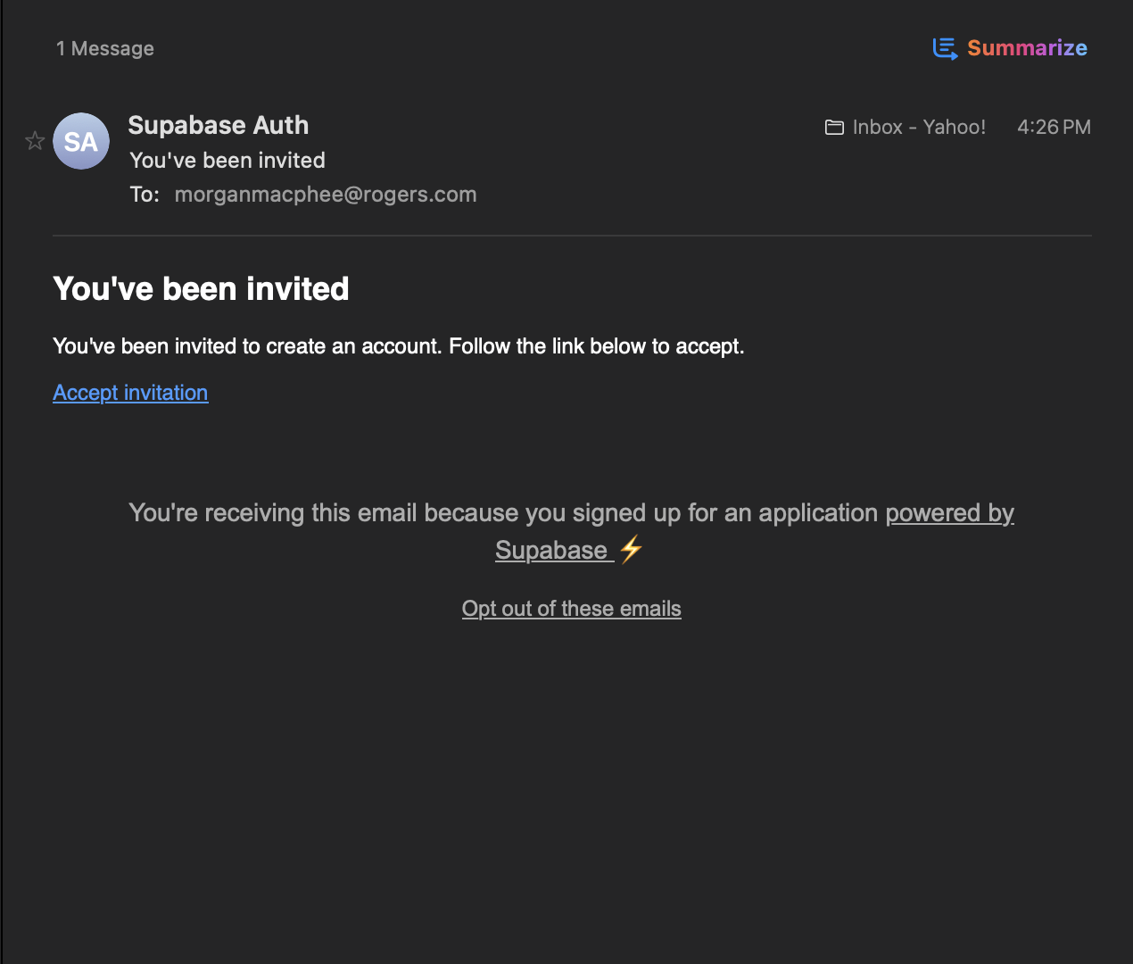
- The user then clicks on the link taking them to a page to setup their password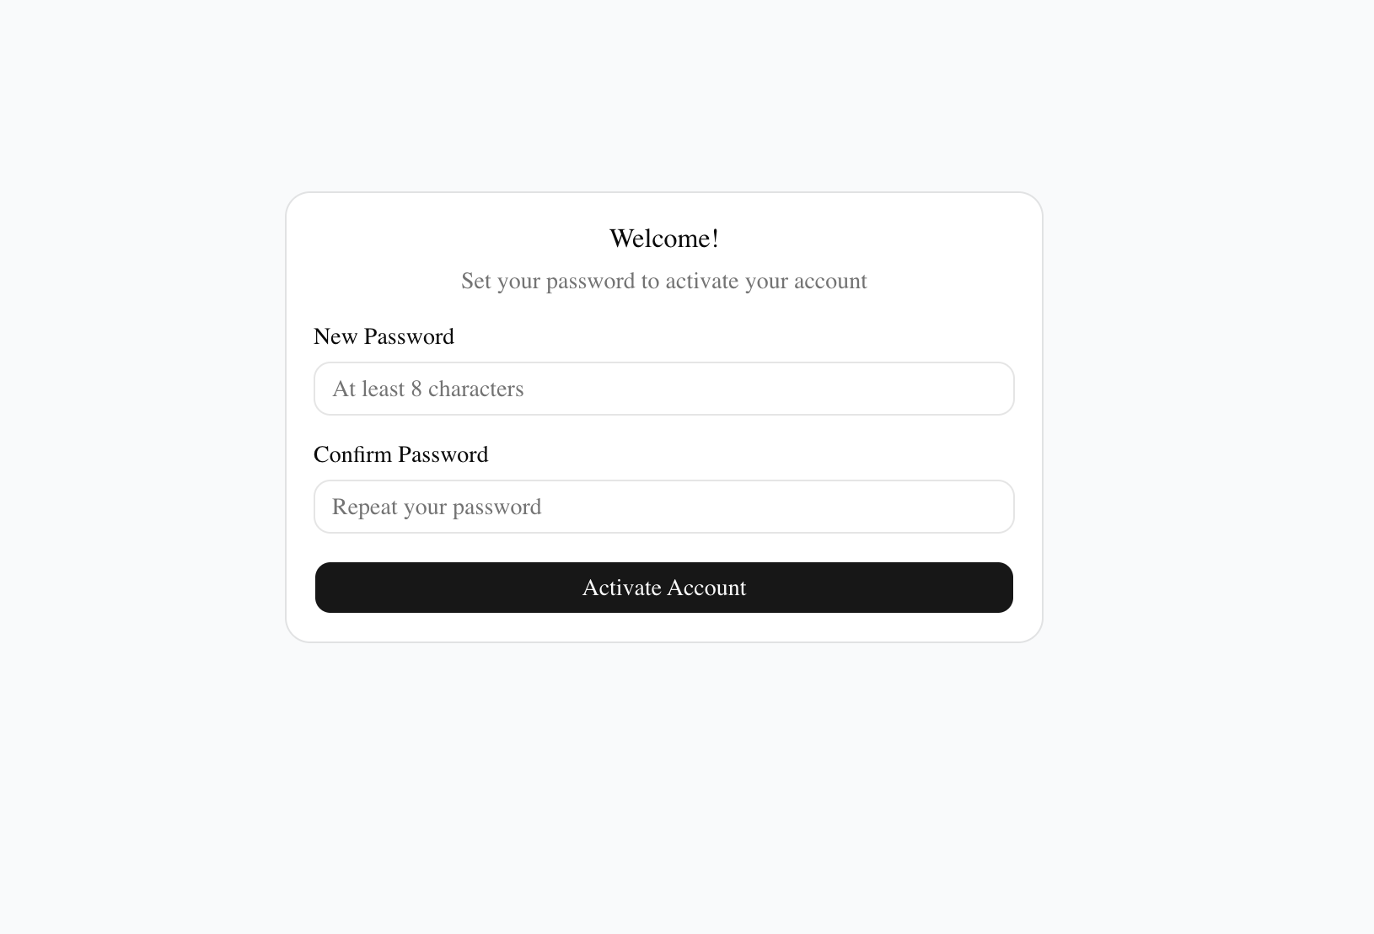
- Once they setup a password, they are taken to the dashboard.

